

Faculty of Informatics and Computer Science

Information System/Computer Networks/Software Engineering/ Computer Science

Lecture

By: Salma Mohamed Yassin

Supervised By

Dr. Mostafa Salama

June 2016
Abstract
Summary of the dissertation within one page. Unnumbered chapter headings, as above, are entered using the Unnumbered 1 paragraph style. The Unnumbered 1 style automatically starts a new page.
This template starts the page numbering at the foot of this page. While you are printing drafts, you might find it useful to add the printing date and time into the footer – to help you, and your supervisor, tell which version is most current.
Note: You are required to submit one extra copy of your title page and Abstract.
It is suggested that the abstract be structured as follows:
- Problem: What you tackled, and why this needed a solution
- Objectives: What you set out to achieve, and how this addressed the problem
- Methodology: How you went about solving the problem
- Achievements: What you managed to achieve, and how far it meets your objectives.

Attestation &Turnitin Report
I understand the nature of plagiarism, and I am aware of the University’s policy on this.
I certify that this dissertation reports original work by me during my University project except for the following (adjust according to the circumstances):
- The technology review in Section 2.5 was largely taken from [17].
- The code discussed in Section 3.1 was created by Acme Corporation (www.acme-corp.com/JavaExpert) and was used in accordance with the licence supplied.
- The code discussed in Section 3.5 was written by my supervisor.
- The code discussed in Section 4.2 was developed by me during a vacation placement with the collaborating company. In addition, this used ideas I had already developed in my own time.

Signature SalmaYassin Date

Acknowledgements
I would like to acknowledge Dr. Mostafa Salama for helping me throughout this project.
Table of Contents
Abstract i
Attestation &Turnitin Report ii
Acknowledgements iii
Table of Contents iv
List of Figures vi
List of Tables vii
1 Introduction 1
1.1 Overview 1
1.2 Problem Statement 1
1.3 Scope and Objectives 1
1.4 Report Organization (Structure) 1
1.5 Work Methodology 2
1.6 Work Plan (Gantt Chart) 2
2 Related Work (State-of-The-Art) 3
2.1 Background 3
2.2 Literature Survey 3
2.3 Analysis of the Related Work 3
3 Proposed solution 4
3.1 Solution Methodology 4
3.2 Functional/ Non-functional Requirements 4
3.3 Design / Simulation set up 4
4 Implementation 5
5 Testing and evaluation 6
5.1 Testing 6
5.2 Evaluation 6
6 Results and Discussions 7
7 Conclusions and Future Work 8
7.1 Summary 8
7.2 Future Work 8
References 9
Appendix 1 10
Appendix 2 – User guide 11
Appendix 3 – Installation guide 12

List of Figures
Similarly you can automatically generate a list of figures from paragraphs of style Figure &Tables. To update this after revisions, right-click in the table and choose Update Field for the entire table.

Figure 1. Highly Technical Diagram 5

List of Tables

Introduction

Overview
Games create engagement which is a necessity for any learning experience. The gaming industry has spent decades to figure how to get people to do relatively repetitive tasks like for example angry birds all you have to do is throw an angry bird on the pigs over and over and over, and they succeeded to make people play for numerous hours a day when there is no mandated purpose at all. We have to learn from that discipline and that is what we call gamification.
This application is all about making lectures more fun to the students to create engagement by classifying questions to lecture slides and having the students solve them while the lecture is going to gain points and set scores.
Classifying questions onto the lecture slides make the lecture more clear and understandable because it breaks the lecture slides into goals by each question. By dividing the slides into goals the student will have more motivation to achieve each goal after the other and in the end this will benefit the students greatly in learning the whole lecture.

Problem Statement
Education is a serious part of shaping our culture, our youth and the foundation of our future. Sadly, while everything is constantly changing and evolving in our daily lives, our ways of teaching remains the same. In universities, the main source for giving academic materials is thought lectures. But since there are no engagement or excitement elements in a lecture, the students tend to not attend lectures if they will not lose attendance points for not attending. Moreover, the students who attend the lecture may usually get distracted, zone out or forget what they have been thought easily. This is a serious problem that needs to be solved. This application is adding gamification elements to lectures to create more engagement and excitement in lectures to make the students want to attend the lecture rather than being forced to attend.

Scope and Objectives
The main scope of this project is to gamify the lectures to induce engagement and excitement into it. So the students would give their total attention towards the lectures, making them remember more of them. By achieving that, we would be enhancing our ways of teaching materials so our students would have a better learning experience. The objectives would be to set a good gamification model in the lectures for the lectures to be actually enjoyable by the students, and be accurate in classifying the questions of the lecture to their rightful places on the slides.

Report Organization (Structure) **not finished
This report is divided into 3 main parts; Introduction, Related Work, and The projects Proposed Solution.
First, The Introduction is divided into six subsections:
- The Overview which gives a general summary to the whole project.
- The Problem Statement which describes the problem this application is solving.
- The Scope and Objective which defines the main scope and goals of this project.
- The Report Organization which describes all the sections that is discussed in this report.
- The Work Methodology which describes the software methodology that is going to be followed in implementing this project.
- The Work Plan which has a Gantt chart that shows the plan of how the project’s goals is going to be divided along the time frame of the project.

Second, The Related Work to the project, which is divided into three subsections:
- The Background which describes what is good and bad gamification and then gives a background on similar projects to this project discussed in the Survey
- Literature Survey which discusses the applications related work applications in depth.
- Analysis of the Related Work which the related work advantages that the project could learn from and apply and disadvantages that the project could avoid in order not to fall in the same difficulties.

Third, The Proposed Solution which is divided into two subsections:
- Work Methodology which describes the proposed solution to the problem statement discussed in the introduction in details.
- Functional/ Non-functional Requirements which explains the main functions that the users can use and the functionalities of the system.

Work Methodology
This project is going to follow the Extreme programming (XP) software methodology. The Extreme programming methodology is a type of agile software development. The agile software development favours evolutionary development, adaptive planning, early delivery, and continuous improvement, and it encourages flexible and rapid response to change (AgileAlliance). Extreme Progrramming involves creativity, learning and improving through trail and error and Iterations. Extreme Programming builds on these activities and coding. It is the detailed design activity with multiple tight feedback loops through effective implementation, testing and refactoring continuously (Extreme Programming). It will be good for this project because extreme programming is based on simplicity, feedback, courage, and respect. XP is a lightweight, efficient, low-risk, flexible, predictable, scientific, and fun way to develop this software about Gamification.

Work Plan (Gantt Chart)
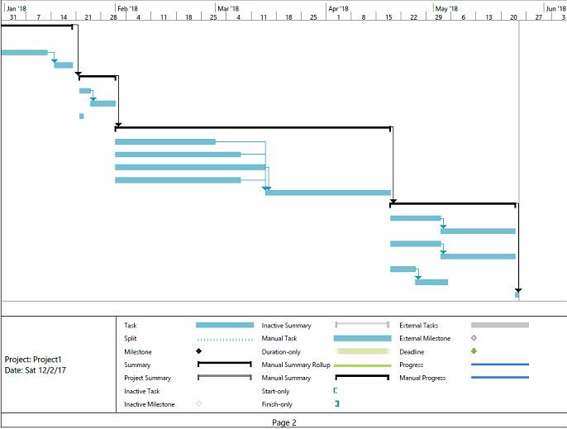
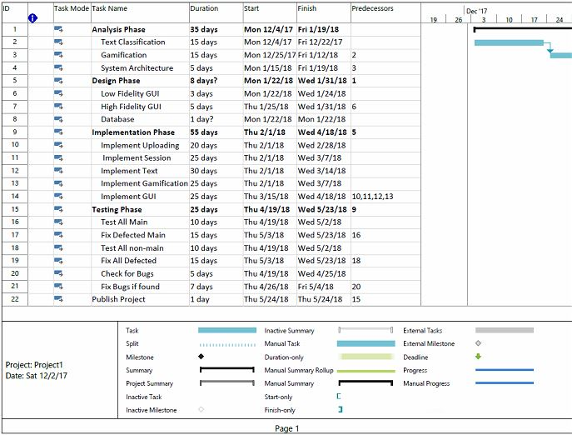

Related Work (State-of-The-Art)

Background
If we are going to set examples for gamification, we need to classify between good gamification and bad gamification. In another words, Function-Focused Design as opposed to Human-Focused Design as Yu-Kai Chou – a researcher in Gamification and Behavioural Design described it (Chou, 2017). He described that most systems are “function-focused” meaning, it assumes that people in the system will take the desired behaviour and it optimizes for efficiency, or usability. The reason why a lot of these function- focused gamification applications fail is because their creators are doing it backwards, they are so obsessed with the gamification elements like points, badges or leader boards and they think if they just take these elements and put it in their product it will automatically become fun and successful However, Human-focused design remembers that people in the system have feelings, motivations, insecurities, and reasons why they do or do not want to do something and it optimizes for that.
A lot of applications have implemented gamification in their education materials. We are going to analyse two gamification applications that targets education. First Duolingo, Duolingo is a language learning application is a very good example to discuss in gamification. Second CodeCombat, CodeCombat is a programming learning application which takes learning code into the next level. By analysing both applications and learning from their success applying the right elements to gamification to the project would be more clear and logical.

Literature Survey
Duolingo is a language learning application; they offer learning material for twenty eight languages. When starting to learn a new language the application asks if you want to start with the basics or if you already know some of the language so that they can give you a small placement test to know which level you are on. The course is separated into levels each level has goals by reaching these goals one by one you score experience points. When you reach certain numbers of experience points the system gives you badges to make you feel rewarded. Once you finish all of the levels the application sends a certificate of completion to your mail address which concludes your journey in learning the language. The student can take multiple languages in parallel and the application would keep motivating him/her to finish each course and be better in these languages (Duolingo).
CodeCombat is an application with designed games to make people learn programming. The game is designed as a fantasy RPG game with a cool energetic audio system that keeps the player want to keep learning. The application targets Beginner to Intermediate levels of coding. At first you would need to sign up to their system to be able to play then you get to choose a character to play with in the game. Then, your character gets sent to the world of the game in which is divided into islands, each island represents a course like Syntax, or loops to greater extents like web development, or game development. Each island is divided into levels your character needs to get through to unlock the other island and to collect gems to be able to buy armour and weapons from the market to fight bigger monsters found in different levels. When entering a level the screen is divided into two sections; the first section is the level needed to pass and the second section is a text editor to write the code guiding the character to pass the level. The game keeps teaching you more code along the levels and islands while you keep gaining points, achievements and gadgets. So, it feels like the player is playing a game but learning in the same time (CodeCombat).

Analysis of the Related Work
These applications have great features that can help this project to be successful and liked by the students. Duolingo may be the best example for gamified education as it keeps the user on track by notifying him/her, sending mails to always be on track, keep your progress, encourages students by badges and points, breaks their big goals into smaller ones by dividing levels, makes you feel like you are a part of something bigger than you by learning these languages. What is great about it Duolingo is that it has a Human-focused design not a function-focused design, it focuses on the human and the things that attracts and attach him/her and that it works on phones, tablets, and personal computers so it is available anytime, anywhere for free and no ads which adds to its availability which attracts people to the service even more. But like any other platform it has some disadvantages too, one being that there is no contact with a real teacher. The students cannot ask specific questions to specialized teachers. Two, The web application is not very usable as the mobile application. Three, the student never loses points, he just keep gaining them which maybe recursive and boresome. CodeCombat also sets a great example in gamifing educational content. The best feature of CodeCombat that it does not only implyes gamification on the content but it is a game. People actually enjoy playing and with that they learn a lot in the way. They implemented the content in the game but that will not be suitable in this project because it dealing with lectures after all. But when it comes to dealing with points, scores and beating monsters to solve a problem and learn something new CodeCombat is great. To conclude, these applications wanted the students to feel proud, successful and achieved to be able to continue playing and learning to induce these feelings into their lifes. By applying the right gamification elements to their systems.

Proposed solution

Solution Methodology

Functional/ Non-functional Requirements

Design / Simulation set up

Implementation

Testing and evaluation

Testing

Evaluation

Results and Discussions

Conclusions and Future Work

Summary
Summarise what you have achieved.

Future Work
Explain any limitations in your results and how things might be improved. Discuss how your work might be developed further. Reflect on your results in isolation and in relation to what others have achieved in the same field. This self-analysis is particularly important. You should give a critical evaluation of what went well, and what might be improved.
References
Use the Reference paragraph style to enter and cross-reference document references. Books [1], standards [2], reports [3], journal articles [4], conference papers [5], and web pages [6] are conventionally presented in slightly different ways.

- Greene, D. and Williams, P. C. Linear Accelerators for Radiation Therapy, Second Edition. IOP Publishing Ltd., Bristol and Philadelphia, 1997.
- ISO. Language Of Temporal Ordering Specification, ISO 8807, International Organization for Standardization, Geneva, 1989.
- Jacobson, J. and Andersen, O., editors. Software Controlled Medical Devices. SP Report 1997:11, Swedish National Testing and Research Institute, Sweden, 1997.
- Turner, K. J. The Rules for Sailing Races on PDAs, J. Navigation, 23(5):114-240, May 2002.
- Ji, H. and Turner, K. J. Specification and Verification of Synchronous Hardware using LOTOS. In Wu, J. Chanson, S. T. Gao, Q. editors, Proc. Formal Methods for Protocol Engineering and Distributed Systems (FORTE XII/PSTV XIX), pages 295-312, Kluwer Academic Publishers, London, UK, October 1999.
- University of Stirling. Computing Science and Mathematics Research Home Page, http://www.cs.stir.ac.uk/research, April 2002.

Appendix 1
You may have one or more appendices containing detail, bulky or reference material that is relevant though supplementary to the main text: perhaps additional specifications, tables or diagrams that would distract the reader if placed in the main part of the dissertation. Make sure that you place appropriate cross-references in the main text to direct the reader to the relevant appendices.
Note that you should not include your program listings as an appendix or appendices. You should submit one copy of such bulky text as a separate item, perhaps on a disk.
Appendix 2 – User guide
If you produced software that is intended for others to use, or that others may wish to extend/improve, then a user guide and an installation guide appendices are essential.
Appendix 3 – Installation guide
If you produced software that is intended for others to use, or that others may wish to extend/improve, then a user guide and an installation guide appendices are essential.

